



Implementation of conditional statements
LAB MANUAL

Disclaimer: The content is curated from online/offline resources and used for educational purpose only
Implementation of conditional statements
Objective:
- Understand how to use conditional statements to control the flow of a Python program.
- Implement various conditions using if, else, elif, and nested statements with different problmes.
Problem Statement:
In real-world applications, programs often need to make decisions based on dynamic input or varying conditions. Without the ability to make decisions, a program would be static, performing the same actions regardless of changing circumstances or input. Here we handling the different problems with different if, for understanding the if concepts. Problems are,
- Checking if a temperature is below freezing point
- To checks whether a number entered by the user is even or odd

Equipment Required:
- Install VS Code - https://code.visualstudio.com/download
- Download Python Installer File - https://www.python.org/downloads/
Prerequisites:
- Basic Computer Skills - Anyone starting to learn computer programming needs basic computer skills. Python is a cross-platform language, so it makes no difference whether you use a macOS, Windows, or even Linux.

Procedure:
Task 1: Implement if statements to check single conditions, To solve the “Checking if a temperature is below freezing point”
Task 2: if-else statements to check single conditions with else, To solve the “ To checks whether a number entered by the user is even or odd”.
Task 3: if-elif-else Statement using Checks multiple conditions in sequence “ To checks the Grading system based on marks”
Task 4: Nested if Statement for more complex conditions, To solve the “Checking if a number is positive, zero, or negative using nested if”

Implementation
Task 1: Implement if statements to check single conditions, To solve the “Checking if a temperature is below freezing point”
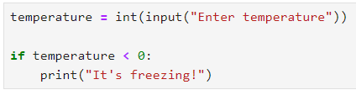T
In above code, the if statement checks a single condition. If the condition evaluates to True, the indented code block is executed.
Output: number
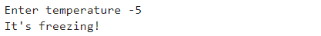
If the user inputs 5, the temperature variable will be 5, and the condition 5 < 0 will be False, so nothing will be printed.

Task 2: if-else statements to check single conditions with else, To solve the “ To checks whether a number entered by the user is even or odd”.
This program demonstrates a simple use of if-else statements to perform different actions based on a condition.

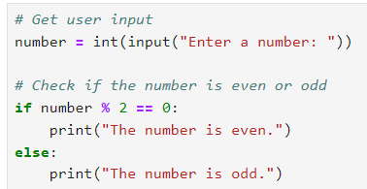
- The program prompts the user to enter a number using input() and converted the values into an integer using i
- Checking even or odd using if statement “% 2 == 0” and evaluates if number is divisible by 2 it is even, if not divisible by2 it is odd
- If the condition is True, the program executes the code block under the if statement, printing "The number is even.".
Output:
If the user enters 32, the output will be,

If the user enters 31, the output will be,

Task 3: if-elif-else Statement using Checks multiple conditions in sequence “ To checks the Grading system based on marks”

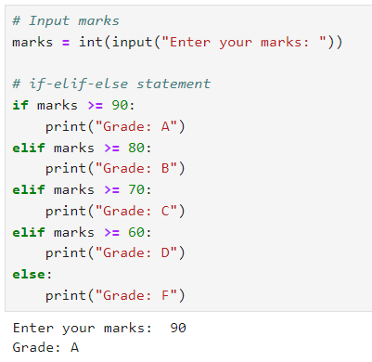

Input: The program prompts the user to input their marks using input(), which are then converted to an integer using int().
Conditional Logic:
- If marks are 90 or above, the grade is "A".
- If marks are between 80 and 89, the grade is "B".
- If marks are between 70 and 79, the grade is "C".
- If marks are between 60 and 69, the grade is "D".
- If marks are below 60, the grade is "F"
Output:
If marks are 90 or above, the grade is "A".

If marks are between 80 and 89, the grade is "B".

If marks are between 70 and 79, the grade is "C".
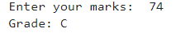
If marks are between 60 and 69, the grade is "D".
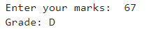
If marks are below 60, the grade is "F"
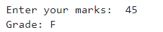

Task 4: Nested if Statement for more complex conditions, To solve the “Checking if a number is positive, zero, or negative using nested if”
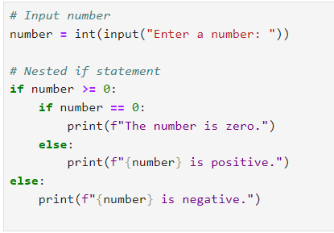
Input: The user is prompted to enter a number, and the input is converted to an integer using int().
Outer if Condition:
- The first check is if the number is greater than or equal to 0.
Nested if Condition (inside the first if block):
- If the number is exactly 0, it prints "The number is zero."
- If the number is positive (greater than 0), it prints that the number is positive.
else Block:
- If the number is less than 0, it directly goes to the else block and prints that the number is negative.
Output:
When the input number is 0
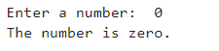
The first if condition checks if number >= 0, which is True because 0 is neither negative nor positive. And then, the nested if condition checks if number == 0, which is also True.

When the input number is a positive integer (e.g., 5),
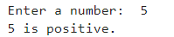
The first if condition number >= 0 is True because 5 is greater than 0. And, the nested if checks if number == 0, which is False, so it moves to the else inside the nested block and prints that the number is positive.

When the input number is a negative integer (e.g., -3),
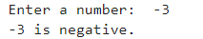
The first if condition number >= 0 is False because -3 is less than 0.Therefore, the program skips the nested if block and directly executes the else block of the outer if condition, printing that the number is negative.

